Weak local site description and surrounding uses  
No assessment of entitlement process or risk  
Decent competitive assessment but not related in recommendations.  
Too much market detail without relation to the recommendations  
Reasonable attempt to relate demand to affordability

***Market Research for***

***8203 NE 159th St, Kenmore, WA 98028***

RE 363 - Development

Institution: University of Washington

Professor: Matt Disston

**Describe the location**

* + The site address is 8203 NE 159th St, Kenmore, WA 98028. Right now there

are not any construction buildings on the site, it is a vacant land. The site is a

flat 11,000 sq ft building lot. It is very close to Inglemoor High School and

Moorland elementary school.

- The site has a triangular shape with dimensions of 165' x 131' x 115' roughly.

The total area of the site is 0.25 Acre.

**Dynamics/activities/land uses nearby**

* + All the buildings near site are for residential use. The neighborhood has

some retail stores and churches. The site is 2.5 miles away from Kenmore

Library, 1.5 miles from Inglewood Golf Club, and 2 miles from lake Washington.

**Transportation characteristics**

* + The site is near 522 Highway, 5 minutes away from the entrance.

Driving is recommended. Bus stops close to site only have Bus 234 and

244. It takes about 10 minutes walk to Inglemoor High school.

**Visibility**

* + Since the site is located at a residential neighborhood, The site's visibility

is limited to the surrounding neighbors only.

**Entitlement requirements**

* + The Parcel Number for the site is 8950500020, based on Kenmore Zoning

Book, the site is Categorized as R-6 (Residential 6 Dwellings Per Acre).

**Physical/environmental characteristics**

* + The site is 2 miles away from Lake Washington, and have golf court and

Saint Edward State Park nearby. Landscape around the site include

bushes and trees. Overall it is a quiet neighborhood area.

**General MSA market dynamics**

* City of Kenmore belongs to King County, which is included in the

Seattle-Tacoma-Bellevue metropolitan division. The population of

Seattle-Tacoma-Bellevue MSA has increased by 1.32% from 2013 to 2017.

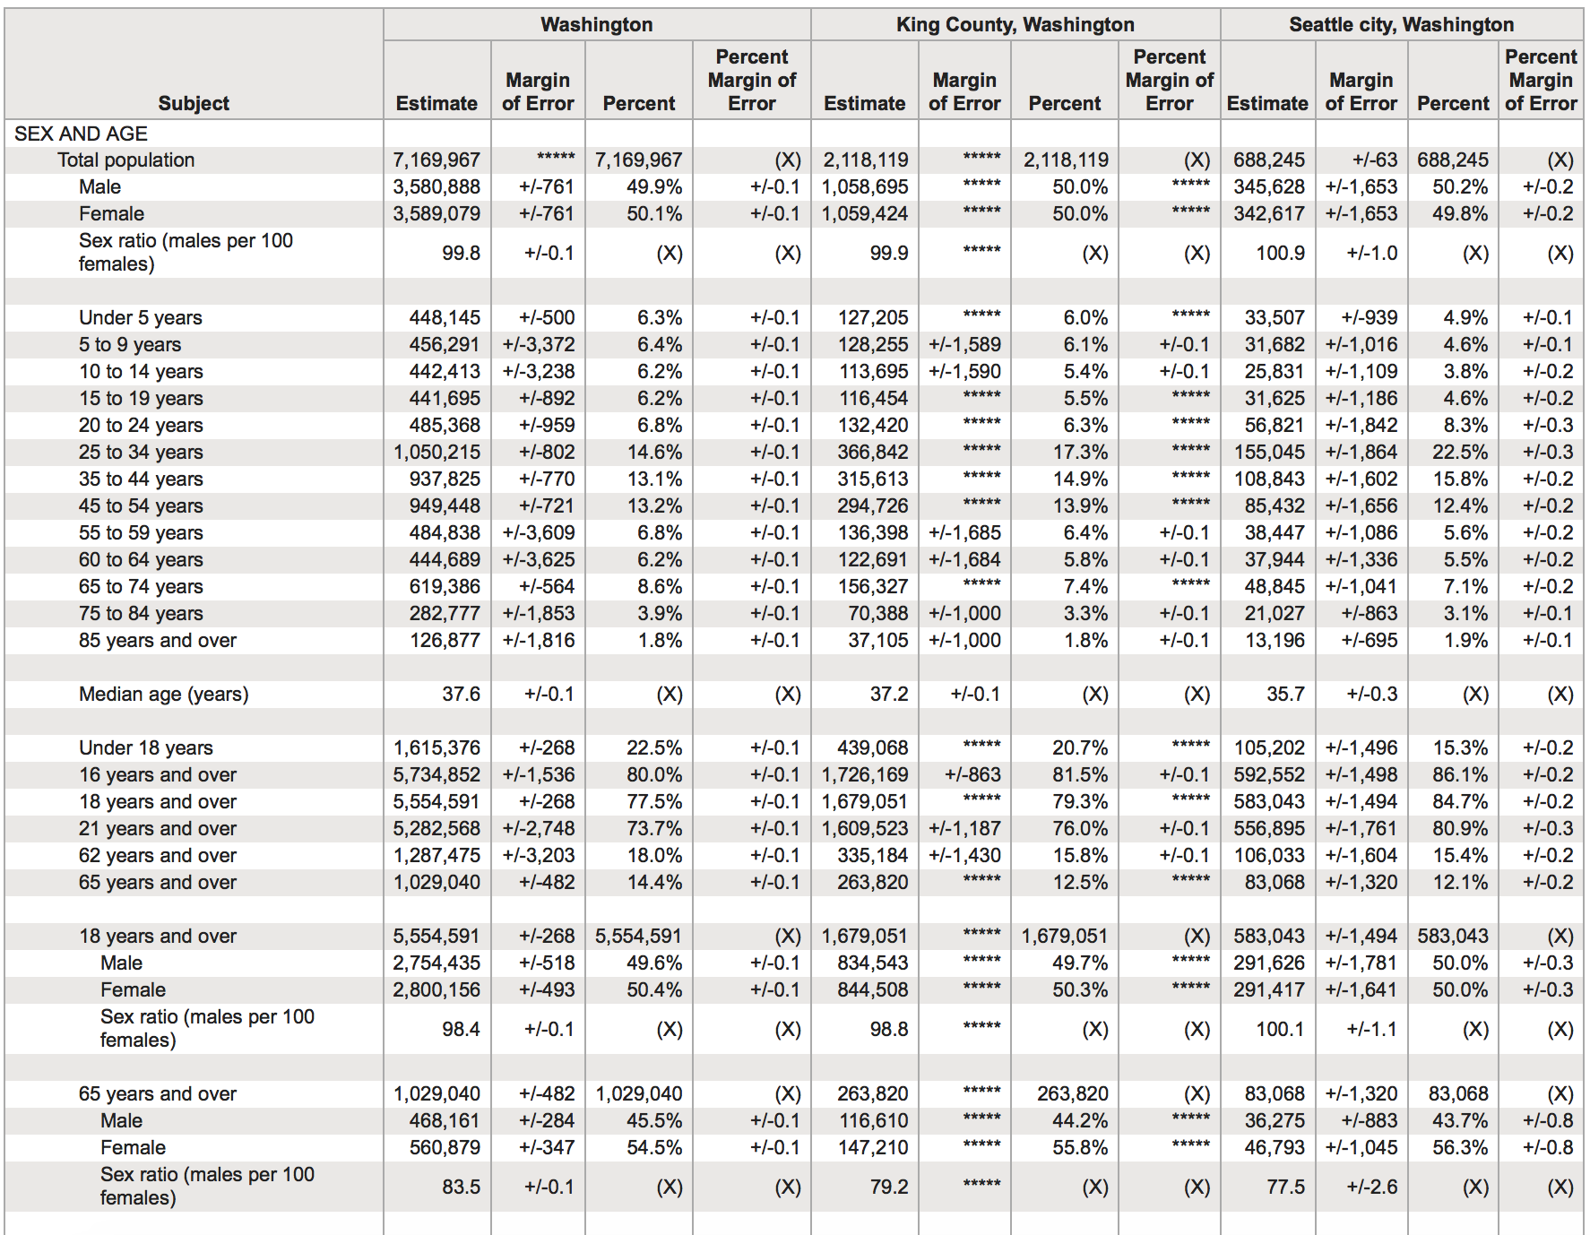

10There are 734777 households in the MSA, 99% are in family households. In married-couple

family households, 66% of the them are married over 6 years. In Seattle City, there are 88105

households, and 98% are in family households.

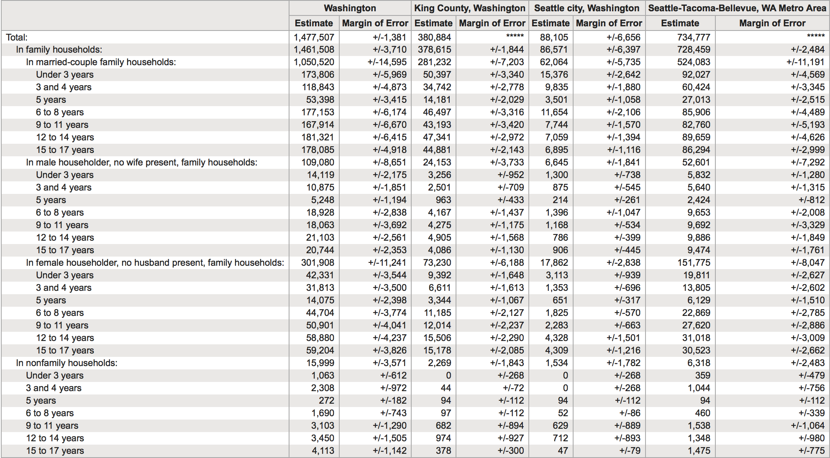

**Trends in the past five years** (*Census tracts used are 217，281.03，220.01，

220.03，221.01，221.02，and 222.01)

*Population*

Total population in the Census Tracts have been increased by 5.2%.

There are more Middle age people in the area. It is not an aging population.

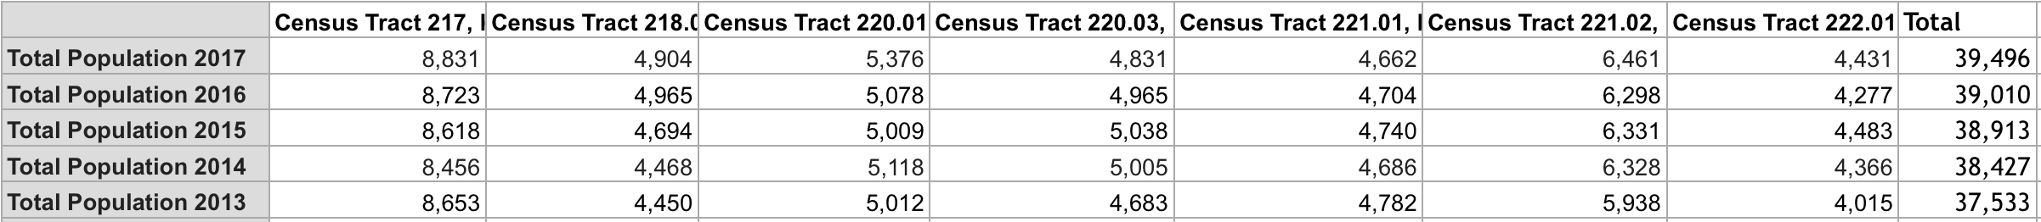

*Households*

In the census tracts, the total household is 15844 in 2017 while a upward trend can be observed during the past 5 years.

*Employment*

From 2013 to 2017, employment rate has increased 2.06%, and unemployment rate has

decreased by 2.5%.

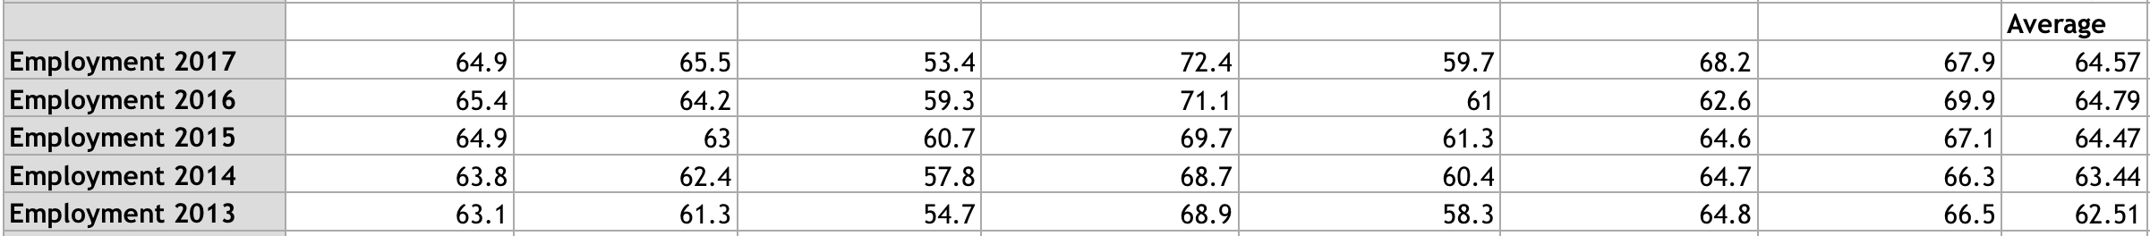

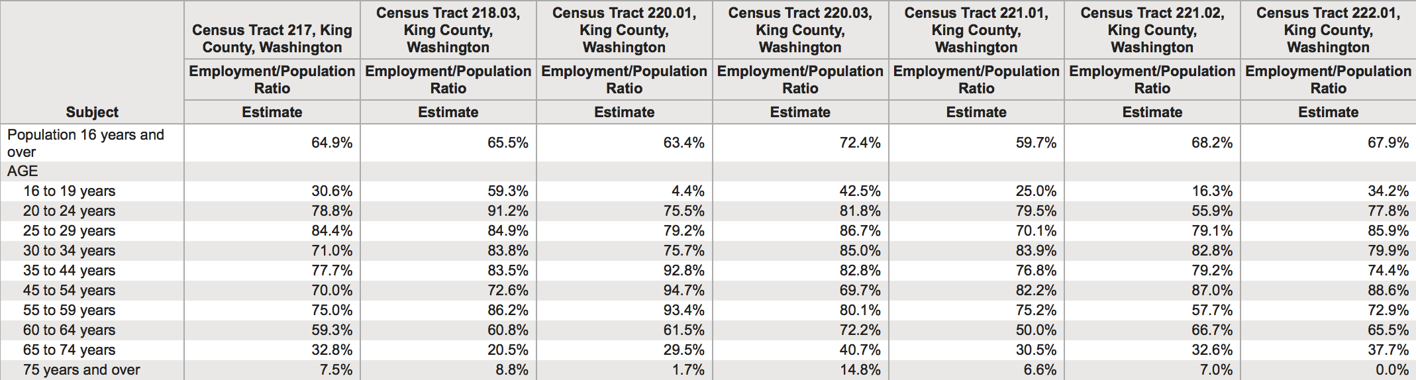

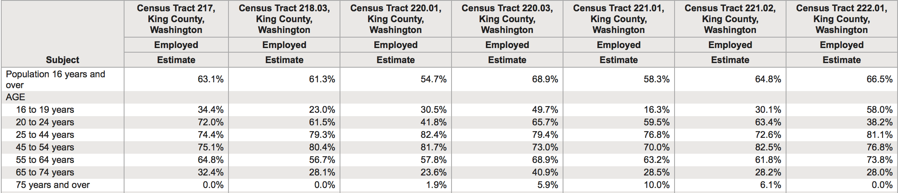

*Income/purchasing power (Retail)*

In the Census Tract, the median earnings of population for the 16 years and over is

$95433/year in 2017, with an increase of 27% for the past 5 years. On the other hands, the per

capita income in the census tracts is average at $45995 in 2017 while a growth of 22% during

past five year.





**Location of development nodes/major retailers**

* The site is 5 minutes driving away from a neighborhood mall, on the North

side of the site, which has retail stores and restaurants, such as Safeway,

McDonald's and Dollar Tree. On the South East of the site is the closest

Inglewood High School. Overall, educational problem and daily needs

could be solved while living on site.

***Identify the local market support***

**Type of User/Customer**

Based on the Zoning Code of Kenmore, this parcel is regarded as residential 6. Given that our neighbors are mostly single-family housing unit, we are planning to provide a similar property to the local market to avoid any potential the opposition from the local community.

Most of properties within the Zip Code 98028 are residential units along with few schools, churches, and retail stores. Based on the market research below, the income level for the community isn’t particularly high, which also indicate that this project should be focus on moderate housing unit instead luxury home. Also, given the highly dependency of car overall, we will also assure that the property will have more than 2 parking lots.

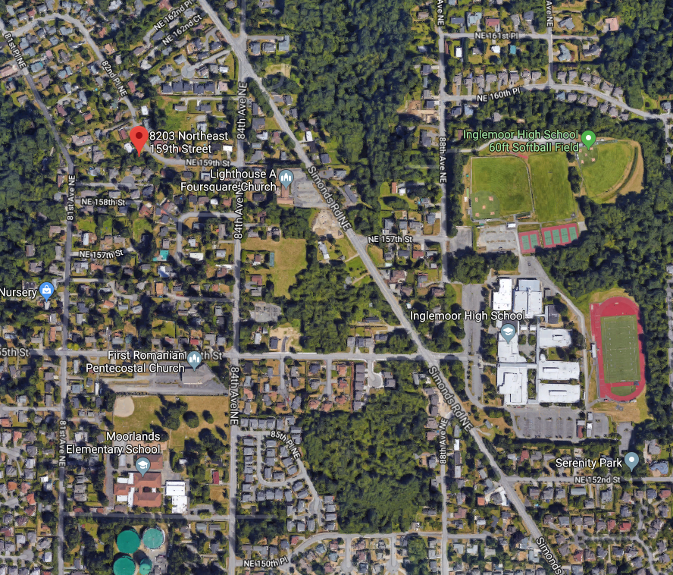

**Income/Ability to Purchase/Rent Within Market**

*Household Income*

According to *Incomebyzipcode*, the average household income within the Kenmore City is similar to the King County, thus, we are not looking at a market that is affordable to luxury houses, while also not particularly poor. Thus, we should lean toward develop a moderate housing.

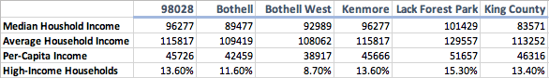

According to *Census*, within the census tracts that we chose, 60% of the households have a median income of more than $75,000; as 48% have a median income of more than $100,000.

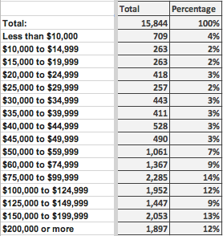

**Existing Competitive Projects**

*Sales*

According to *Trulia*, the median sales price in Kenmore City has been trending up since 2014, as of January 2019, the median sales price is around $628,750. Also, the number of sales in Kenmore City has been lingering from 50~150 since 2014. However, since the third quarter of 2018, the number of sales has been trending downward.

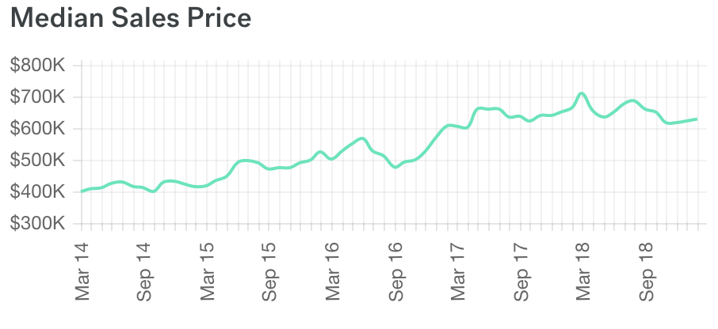

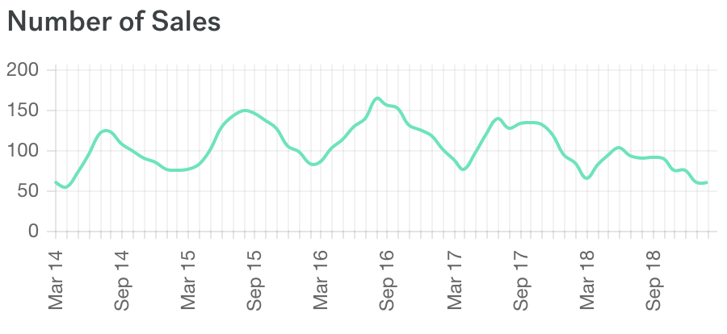

*Price Per Square Feet*

According to *Zillow Research, the price/s.f.* in Kenmore city has been trending upward since 2013 and currently located at $325/s.f. from $174/s.f. in Jan 2013.

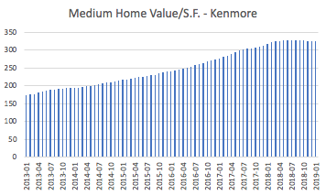

*Rent*

1. *Median Rent & Number of Rentals in Kenmore* (From Trulia)

According to Trulia, the median rent in Kenmore was top at $2,800 per month in Jun. & Jul. 2018 while low at $2,400 per month currently. Furthermore, the number of rentals was trending up since March 2018, and suddenly dropping since Nov 2018, with 31 per month currently.

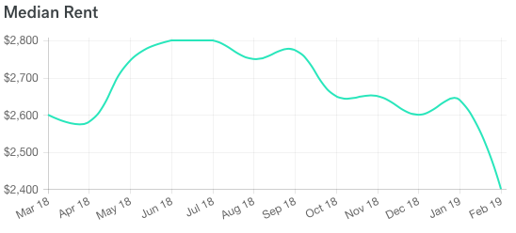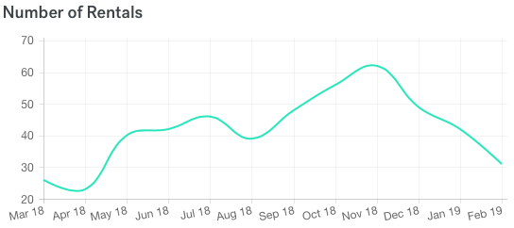

1. *Market Rent Per SF*

Interestingly, according to *Costar*, we get a different picture where the market rent per sq. ft. is still increasing recently. The difference in two data might be explained by the increase in lower square feet unit, such as apartment, in Kenmore City.

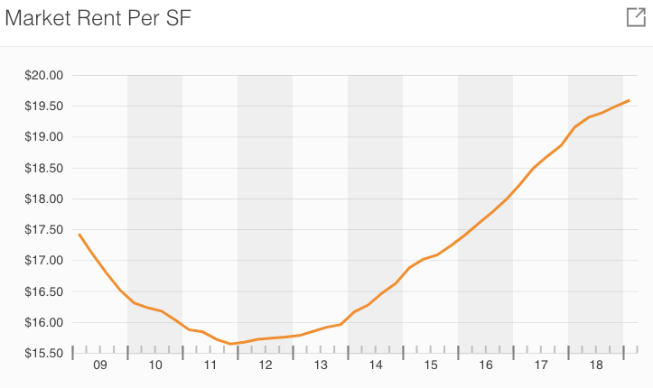

1. *Gross Rent*

According to *Census*, we are looking at the similar data that were presented at *Trulia*, where 66% of the renter are paying between $1000 ~ $2499, with a total of 5,084 household that are renting with cash rent in City of Kenmore.

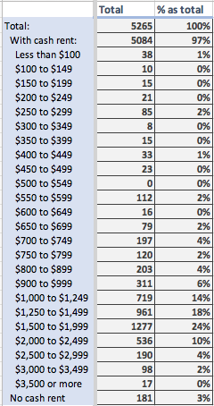

*Amenities/Specialty Characteristics*

15According to *Census*, there is total of 15,844 units within the census tracts that we chose, as 67% are owner-occupied and 33% are renter-occupied. While 64% of these properties are single family and 20% are 10+ unit apartment, 85% of the owner-occupied housing units are single family and 50% of the renter-occupied are 10+ unit apartments.

Moreover, 72% of the total units were built in 1960~1980 while only 20% of the units were built after 2000. Among the total housing unit 87% are more than 2 bedrooms, as 99% of the owner-occupied units are more than 2 bedrooms. The renter-occupied units have 29% as 1-bedroom unit and 62% as more than 2-bedroom unit.

One thing worth notice is that only 6% out of the total housing unit have no vehicle available, as 2% more owner-occupied and 15% for renter-occupied.

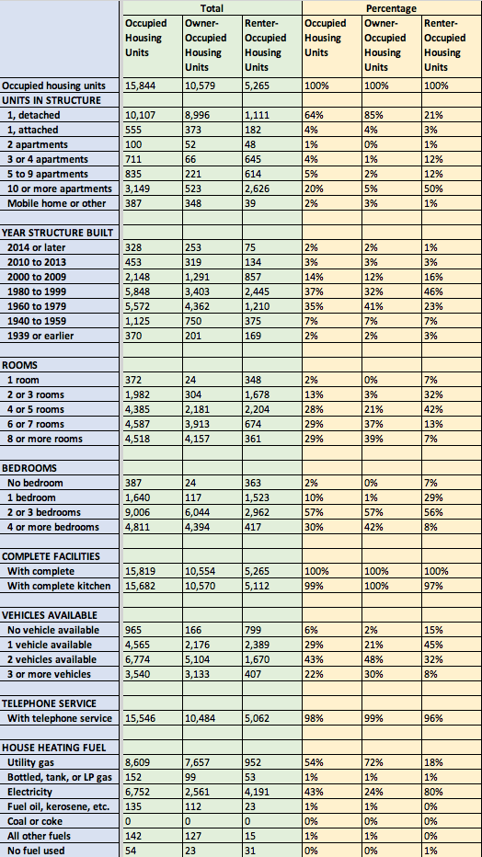

*15Competitive Visibility and Transportation Strengths and Weaknesses*

The neighborhood that our parcel located is a highly car-dependent bedroom community without much access to the public transportation including bus station. Furthermore, there isn’t any advantage in visibility for this parcel as well. However, these step-backs were shared with our potential competitors within the neighborhood as well. Given the weak visibility and transportation in the overall neighborhood, we don’t regard the lack of transportation and visibility as a weakness for our parcel.

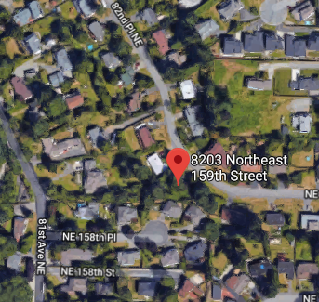

*Absorption*

According to *Zillow Research*, we use the “Sale to List” to capture the absorption rate in Kenmore. Based on the graph below, we are looking at an average of 0.95 sale to list ratio in Kenmore, which present as a healthy market where there is no excessive oversupply or undersupply.

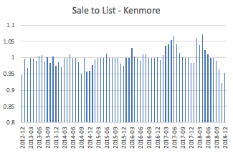

According to *Costar*, we will get a similar picture where the net absorption in Kenmore City has been lingering around 0 in general since 2009.

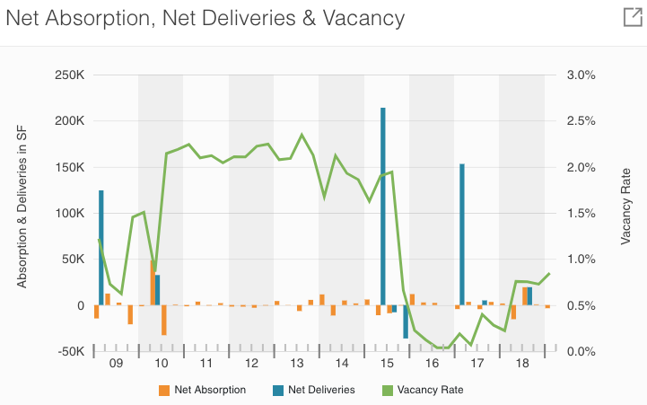

**25Estimated Demand**

*Population Move-In*

According to *Census*, there has been continuous population move-in since 1980, and within 2010~2014 there are 7,284 household move-in to owner-occupied unit. Given this data is published in 2017, we cannot get the very clear picture for current move-in within the Census Tracts that we chose.

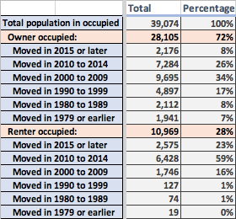

Based on the estimation from *Costar*, we are looking at 7.6% population growth rate in next 5 years and a very low (0.2%) 12-month net absorption % of inventory. Furthermore, the current median of housing on market is 4.2 months, moreover, Kenmore city currently has a median of housing unit vacant of 6.4 months. All of these are indicating a high demand for the housing.

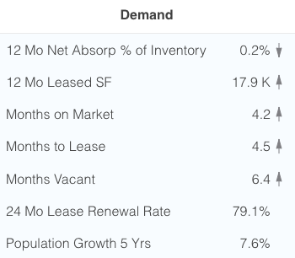

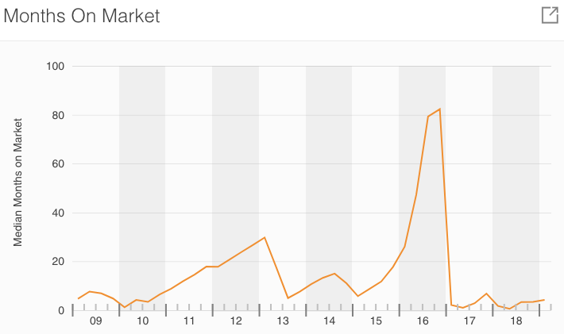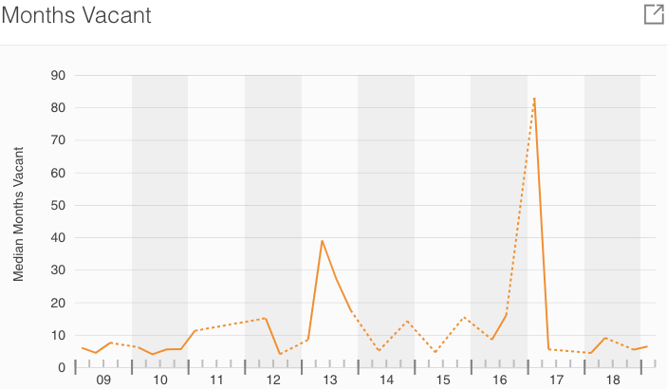

**Estimated Competitive Supply**

*First – Housing Units*

According to *Census*, the housing units within the census tracts that we chose has been increasing overall with an average of 1.6% growth rate for the last four year. This indicated a potential of 257 new units per year.

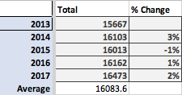

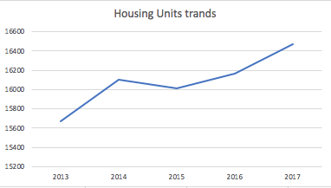

According to *Costar*, there are 10,000 square feet under construction at the first quarter of 2019, with 20,200 square feet of current available space. This shows a potential 30,200 square feet of supply within next 6 months.

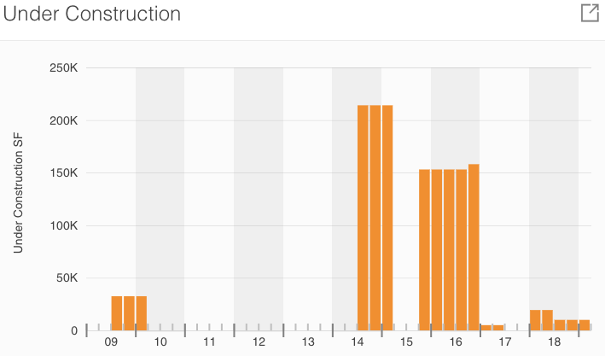

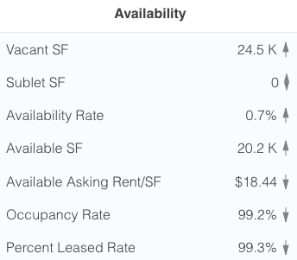

**15Opportunities/Constraints & Recommendation**

*Opportunities/Constraints*

The biggest opportunity present in this project is the low price for this project. Given the average lot price of $75.8/s.f. for recently sold units around the parcel, we are looking at sales price of $22.07/s.f. for this lot. Furthermore, based on the zoning code that the minimum requirement of 5400 square feet for residential 6, we could potentially split the parcel into two and build two unit on it with an average market price of $325/s.f. or rent it out with the average market rent rate of $19.5/sf. Even though we might fail to split the parcel into two, this parcel still presents sufficient room for profit. Moreover, since the Sewer, water, power, and gas are available on the street, this could also save us lots of cost on the improvement to the land. Even though we are not looking at an unhealthy market that is either oversupply or undersupply, Kenmore City still present a healthy growth and a balance between demand and supply overall.

However, given the lack of access to public transportation, this might essentially limit our buyers to car owner. Moreover, even though there are still new houses being built and sold recently in the neighborhood, most of the properties in this neighborhood were built during 1960s~1980s. Thus, we are still uncertain that whether or not the local community will oppose any new construction or the younger generation such as millennial will be willing to move into somewhere that need to drive to work.

One thing to add on is that the price for housing in Kenmore City has been increasing in a very high rate, which might indicate a bubble in this market. Furthermore, the Fed has been increasing the interest rate since last year and the global economic have started to show some signal of slowing down, this might suggest that the direction economic will be reverse at some point within one to two year.

*Recommendation*

Given the price of this parcel and the market analysis that were presented above, we will recommend to purchase this parcel and attempt to split this parcel into two lots. By building residential units on both lots, this could potentially generate most of the profit out of this project. However, we should also be cautious that the economic is starting to show some sign of unstable and the direction of the economic might turn at some point of near future. Thus, we would recommend take on less leverage and potentially a fixed rate mortgage to transfer the interest rate risk to the lender. Furthermore, some of the more detail research, such as environmental report, construction cost analysis, etc., particular to this parcel should also be done before the purchase

**Appendix**

Appendix A. – Basic Information & Analysis to the Parcel

**Address:** **8203 NE 159th St, Kenmore, WA 98028**

**Parcel #: 8950500020**

**MLS #: 1086893**

**Price: $250,000**

**Lot Size: 11325.6 s.f. = 0.26 acre ($22.07/s.f.)**

**Zoning: Residential 6**

**Average Price in Neighborhood:**

**Lot ($/s.f.): $75.82**

**Floor ($/s.f.): $330.19**

**Feature:**

**Inglemoor High School**

**Sewer, water, power & gas available.**

**Potential:**

**2 units (5662.8 s.f. Lot size per units) -> Pass the minimum 5,400 s.f.**

**Assumption:**

**Floor Size: 2500 s.f.**

**Sales Price (Based on Market Average): Average of the three: $632273 / property => $1.26 M**

**<Lot Based: $409320. Home Price Based: $825000. Similar Project Based: $662500>**

Appendix B. – Zoning Map

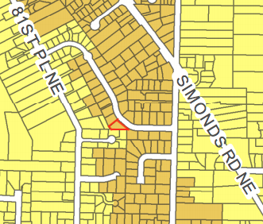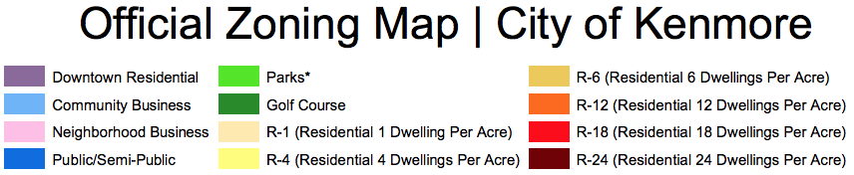

Appendix C. – R-6 Zones Allowances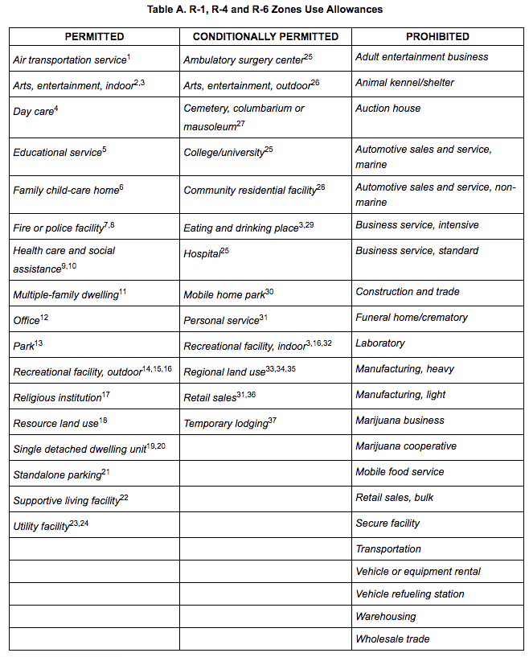

Appendix D. – R-6 Development Standard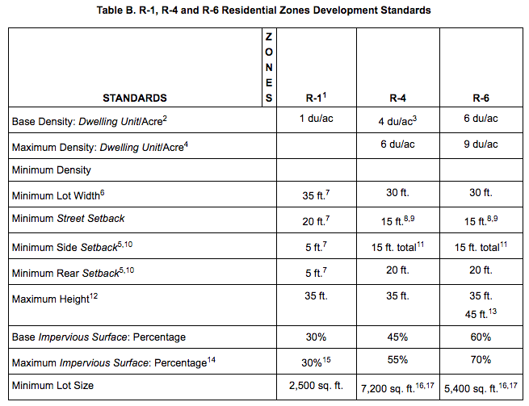

Appendix E. - (Census Tracts 217, 218.03, 221.01, 221.02, 220.01, 222.01, 220.03)

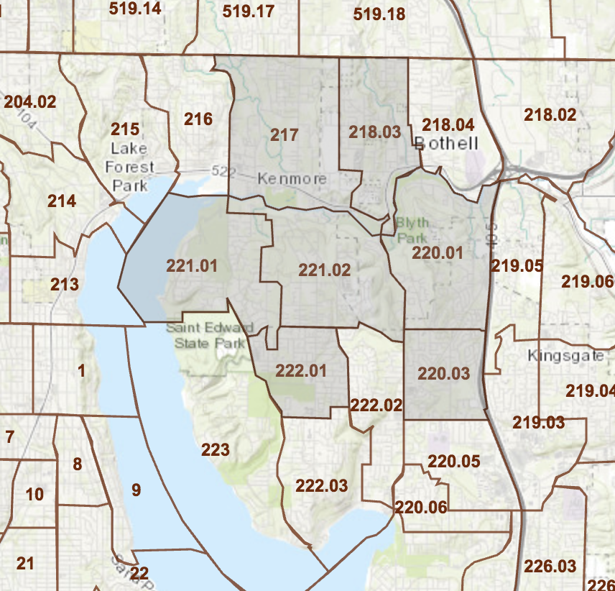

Appendix F. – Market Condition from Zillow Listed around The Parcel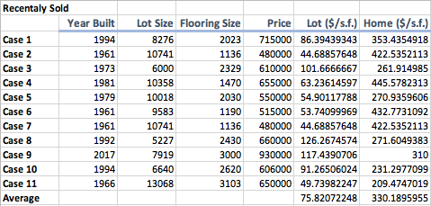

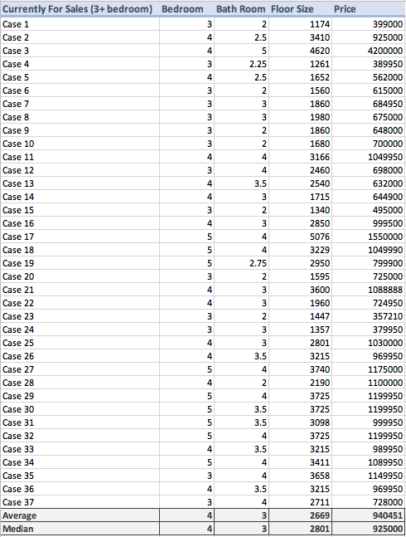

**Site Used**

Zillow – Parcel Listed

<https://www.zillow.com/savedhomes/for_sale/96660212_zpid/1_pnd/47.748752,-122.224328,47.732677,-122.241709_rect/15_zm/1_rs/1_fr/>

Zoning Regulation - Kenmore

<https://www.codepublishing.com/WA/Kenmore/html/Kenmore18/Kenmore1821.html#18.21>

Zoning Map - Kenmore

<http://kenmorewa.gov/sites/default/files/Development_Services/2015%20May%20Kenmore%20zoning_600dpi.pdf>

Income By Zip Code

<https://www.incomebyzipcode.com/washington/98028>

Trulia - Kenmore

<https://www.trulia.com/real_estate/Kenmore-Washington/market-trends/>

Zillow – Research Center

[*https://www.zillow.com/research/data/*](https://www.zillow.com/research/data/)

CoStar – Kenmore (KPI)

<https://product.costar.com/search/all-properties/analytics/kpi>

Census – Factfinder

<https://factfinder.census.gov/faces/nav/jsf/pages/index.xhtml>