5004 17th ave ne Seattle, wa 98105

Final Project 185

University of Washington

Winter Quarter 2019

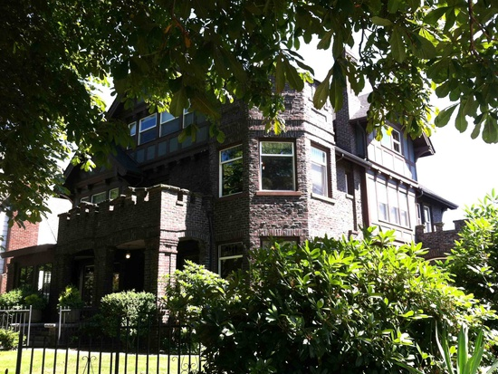

Good local description, transportation   
Lacks description of likely impact on the site   
Decent transportation and visibility sections

Almost enough on the entitlement challenges. Should have talked to the City.  
Good regional and local market data and assessment . Relation to the recommendations not entirely clear

No competitive analysis whatever.

R E 363

Matt Disston

Assignment (Final Project)

**Location of Site:**

* The location of the site that I have decided to work on is located on the corner of 17th and 50th. The exact address of this property is 5004 17th Ave Ne Seattle, WA 98105. This site is located on Greek row on the University of Washington Seattle campus.

**Dynamics/Activities/Land uses nearby:**

* This property is nearby, nearby land use. many different areas to shop, dine, and even access to transportation to be able to make it to downtown Seattle in about five to ten minutes. University Village is a very popular shopping center located about 3 minutes away from this location and is home to many shops as well as restaurants.
* University District is also close to this location which is about a 5 minute walk away where you can dine as well as do some light shopping and have access to the University of Washington Campus where you can explore the campus as well as take in many different sites such as the Cherry Blossom Trees and the Drumheller Fountain to get a great view of Mt. Rainier. This area is in a residential location, so it is near many different types of homes as well as being across the street from a local church known as Church home.
* This site is also close to many different schools. The closest school being Roosevelt High School.

**Transportation Characteristics:**

* !!This location is very close to the Light Rail. It takes about 15 minutes by foot to reach the Light Rail which is located right next to Alaska Airlines Field. There are also a number of bus stops located right outside of this property. There are a number of transportation options when it comes to the location of this property, so it is never difficult to get to where you need to go. The bus stops are able to take passengers in and around Seattle all you would have to do is research which routes take you where you would need to go.

**Visibility:**

* !!This property is located at 5004 17th Ave Ne, Seattle, WA 98105. This property is three stories tall and is very visible from all sides with no blockage from plant life or other structures. The only way you wouldn’t be able to see this property is if you go down the declining streets on either side of the property that go north and south. This building is very easy to identify due to it being on the corner of both 17th as well as 50th.

**Entitlement:**

* This property is a standard home and is in order for all entitlement requirements. The building is approximately 8910 square feet and is a part of Seattle Public Utilities. Since it is a Residential property located in the University District of Seattle, if you were to park it would be a zone six requirement. Everything else about this property is up to code and does not interfere with any local ordinates.

**Physical and Environmental Characteristics:**

* This property is a single family detach and the outside is made up of brick. This property is three stories tall with a front patio deck along with a backyard that comes with a homemade basketball court along with a parking space in the front but no garage. This house was built in 1914 and has 22 beds and 0.75 baths. This home has many large trees in front of the property and has a great view of Mt Rainier on the third floor. This property if purchased will need some attention to the lawn as the grass needs some tending to, but other than that the property is a great place.

**Describe the general MSA market dynamics – General tabular analysis -- Big to small (State, county, selected local cities, site market or trade area):**

* This property is located in Seattle, Washington and the county that it resides in is King County. This county is home to a large population. King County itself has about 2,105,000 people as stated in 2016. About 686,600 of those people live in Seattle alone. The average hourly wage in this county is about 28.94 per hour which is about five dollars more than the state average. These high wages explain why the housing market is some of the most expensive in the entire state and even the country. The average national home values in the country are about 223,900 while the average home value in Seattle is about 488,400 which is much higher than the national average. However, the average home value in King County is about 618,100.

**What are the Trends in the past five years?**

* **Population:**
  + In King County, the total population is around 2,190,200 people which has gone up 13.4 % since the year 2010 which was eight years ago. In the table below, it talks about the estimated population increase from 2010-2015.

|  |  |  |  |  |  |
| --- | --- | --- | --- | --- | --- |
| **2010** | **2011** | **2012** | **2013** | **2014** | **2015** |
| 1.20% | 0.60% | 0.70% | 1.30% | 1.80% | 1.80% |

* **15Households:**
  + In King County there is a total of 902,107 housing units. In the graph below, it shows data from the years of 2010-2015 showing the number of total housing permits which include, Single-family Units, Multi-family units, Units in 2-unit Multi-Family Structures, Units in 3 and 4-unit Multi-Family structures, and Units in 5+ unit multi-family structures.

|  |  |  |  |  |  |  |
| --- | --- | --- | --- | --- | --- | --- |
| **Housing Permits** | **2010** | **2011** | **2012** | **2013** | **2014** | **2015** |
| King County | 6,020 | 6,143 | 11,614 | 12,277 | 14,703 | 18,537 |
| Single-Family Units | 2,578 | 2,765 | 3,864 | 4,419 | 4,215 | 4,010 |
| Multi-Family Units | 3,442 | 3,378 | 7,750 | 7,858 | 10,488 | 14,527 |
| Units in 2-unit Multi-Family Structures | 110 | 84 | 130 | 188 | 388 | 336 |
| Units in 3- and 4-unit Multi-Family Structures | 148 | 114 | 156 | 219 | 273 | 471 |
| Units in 5+ Unit Multi-Family Structures | 3,184 | 3,180 | 7,464 | 7,451 | 9,827 | 13,720 |

* **Employment:** 
  + For this first graph, it will show data from 2014-2019 where it will show the estimated employment from 2014-2019 and the next graph will show what kinds of jobs people have. In King county, between the years of 2014-2019, the annual growth rate of jobs was 2% in 2014 and went up to 2.2% in 2019 so there was a slight increase in the annual growth rate.

|  |  |  |
| --- | --- | --- |
| **Occupation** | **Estimated employment 2014** | **Estimated employment 2019** |
| **Total, All Occupations** | **1,387,071** | **1,529,899** |
| **Management Occupations** | **87,727** | **97,702** |

* **15Income/Purchasing Power:**
  + For King County, the median household income is about 83,571 dollars and the data that will be displayed will showcase the average household income from 2010-2015. It will also show the household income range from 2011-2015.

|  |  |  |  |  |  |  |
| --- | --- | --- | --- | --- | --- | --- |
| **Year** | **2010** | **2011** | **2012** | **2013** | **2014** | **2015** |
| Median Household income | $71,303 | $72,330 | $71,266 | $73,170 | $76,099 | $81,916 |
| Median Family Income | $90,943 | $94,106 | $91,008 | $94,492 | $98,379 | $102,207 |

|  |  |  |  |  |  |
| --- | --- | --- | --- | --- | --- |
| **King County Households by Income Range** | **2011** | **2012** | **2013** | **2014** | **King (2015)** |
| Less than $10,000 | 5.8% | 5.8% | 5.9% | 5.6% | 5.0% |
| $10,000 to $14,999 | 3.6% | 3.3% | 3.3% | 3.0% | 2.7% |
| $15,000 to $24,999 | 7.3% | 7.3% | 7.1% | 6.7% | 5.4% |
| $25,000 to $34,999 | 7.7% | 7.6% | 7.6% | 7.1% | 6.9% |
| $35,000 to $49,999 | 10.9% | 11.1% | 11.4% | 11.1% | 10.2% |
| $50,000 to $74,999 | 16.2% | 17.2% | 16.0% | 15.9% | 15.6% |
| $75,000 to $99,999 | 13.4% | 12.5% | 12.5% | 12.0% | 12.9% |
| $100,000 to $149,999 | 17.5% | 17.5% | 17.0% | 18.3% | 18.8% |
| $150,000 to $199,999 | 8.2% | 8.3% | 9.0% | 9.3% | 9.7% |
| $200,000 or more | 9.3% | 9.4% | 10.3% | 10.9% | 12.8% |
| $150,000 to $199,999 | 8.2% | 8.3% | 9.0% | 9.3% | 9.7% |
| $200,000 or more | 9.3% | 9.4% | 10.3% | 10.9% | 12.8% |

* **Location of Development nodes/ major retailers:**
  + The graph below will showcase the taxable sales that occurred from 2004-2016 in King County. This graph is also adjusted for inflation.

**Opportunities and constraints of the site/project (My own opinion):**

* This property would be ideal home for a larger single family. This property is at an ideal location and has easy access to multiple shopping centers as well as having access to the Light Rail which gives people the opportunity to get to downtown Seattle as well as other parts of the greater-Seattle area. This property is located at the University of Washington and gives people the opportunity to explore the campus as well as attend it. I believe this property is a great place to either raise a family or live with friends.

**Identify the local market support:**

* **Type of user/customer:**
  + The type of customer that should be shopping for this property would be single families as well as someone who would be willing to rent out this property to people who either live in the University District or people who attend the University of Washington.
* **Income/Ability to purchase/rent within market/trade area:**
  + As stated above, the average income of the people that would be able to purchase this home would be the ones that are making about 150-200,000 dollars a year which is about 12.8% of the population of king county.

**Profile existing competitive projects:**

* **Price/rent/sales:**
  + The existing competitive project is located at 5011 17th Ave NE Seattle, WA 98105. The property has eight beds and four and a half baths. This property is in the same vicinity as my project and is the same distance away from transportation, shopping, and dining as well as being close to the University of Washington. The property is currently being appraised at 1,804,145 which is about 200,000 less than my property. However, this property has more bathrooms which makes it more demanding to the market.

**Calculate/Project Demand:**

* 15The table below showcases the number of rental properties in the Seattle Area as well as the Sale properties. The overall rental housing market in the HMA is tight, with an estimated vacancy rate of 4.0 percent, down from 7.1 percent in April 2010. Apartment market conditions are tight, with a 4.8-percent vacancy rate during the first quarter of 2017, down from 5.3 percent a year earlier, and the average asking rent increased more than 7 percent, to $1,606 (Reis, Inc.). Demand is estimated for 32,750 new, market-rate units during the forecast period. The estimated 20,800 units currently under construction will meet a portion of the forecast demand.

|  |  |  |
| --- | --- | --- |
| **Seattle HMA** | **Sales Units** | **Rental Units** |
| Total Demand | 33,500 | 32,750 |
| Under Construction | 3,250 | 20,800 |

**Estimate/project competitive supply:**

* For projected competitive supply, it is predicted that in 2019, the number of homes that will be listed as active listings will increase from -20% to up to 150% due to the number of jobs that are becoming available.
* 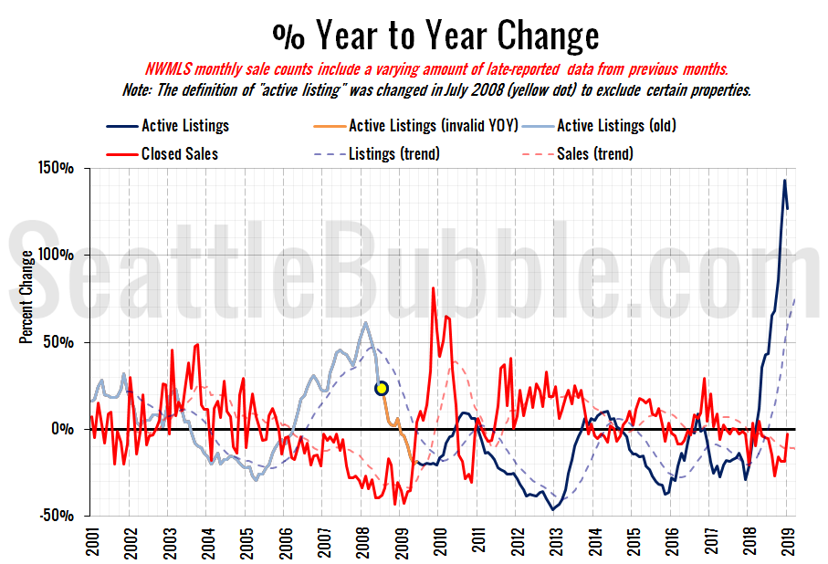



**???**

**15Opportunities and Constraints:**

* This property is in a great location. It is close to shopping as well as dining and is in close proximity to the University of Washington and is able to house more than one family. A few constraints would be not having a view of the mountains and also the amount of traffic that occurs on the cross streets near the house.

**Recommendations:**

* 15If I were to make any recommendations for anyone wanting to purchase this property, I would tell them that it is in a great location and it would be a great place to either raise a family or rent out to a number of college students who would be willing to pay the rent.