Don’t make statements in the first person. Not “I recommend” rather “The recommendation is”

Good locational description relative to surrounding uses and situs.

Good, detailed assessment of transportation assets and marketing visibility window.

Market demand is keyed to the site but gives no regional context.

Good summary of local demand segments and likely market impacts.

Adequate affordability analysis and good competition detail.

Passable Ops and cons, recommendations were clear but could have had better support.

Final Project RE 363

“The well M in Seattle”

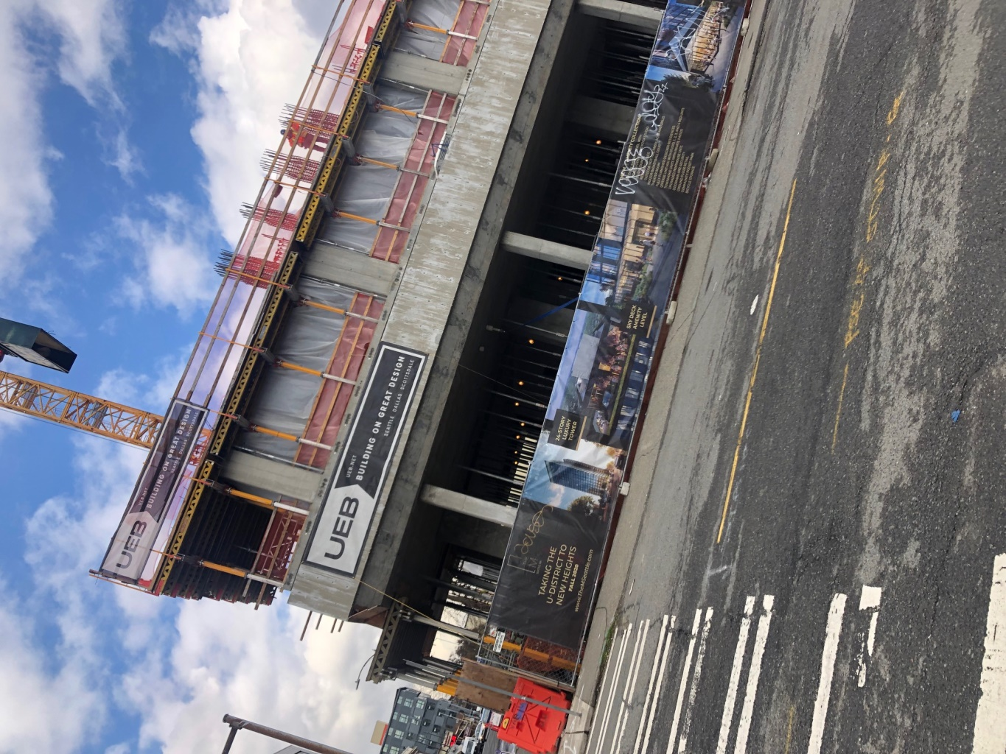

My project involves a residential college student housing that is currently under construction. The apartment is called “The M” and on their website they describe their units as “fully furnished designer residences with luxury amenities”. It is located 4700 Brooklyn Ave NE in the 98105-area code. It is in the primary stages of construction, and the apartment complex is planned to be 24 stories tall and will be aiming at housing students and younger people. The company is planning to offer studio, one, two, three and four-bedroom residences. I thought it would be interesting to analyze and investigate the market for this residential housing and learn more about the area around.

Don’t bother telling me what you are going to do, just do it

I am going to describe and analyze these factors around the area:

* Location
* Dynamics/activities/land uses nearby
* Transportation characteristics
* Visibility
* Entitlement requirements
* Physical/environmental characteristics

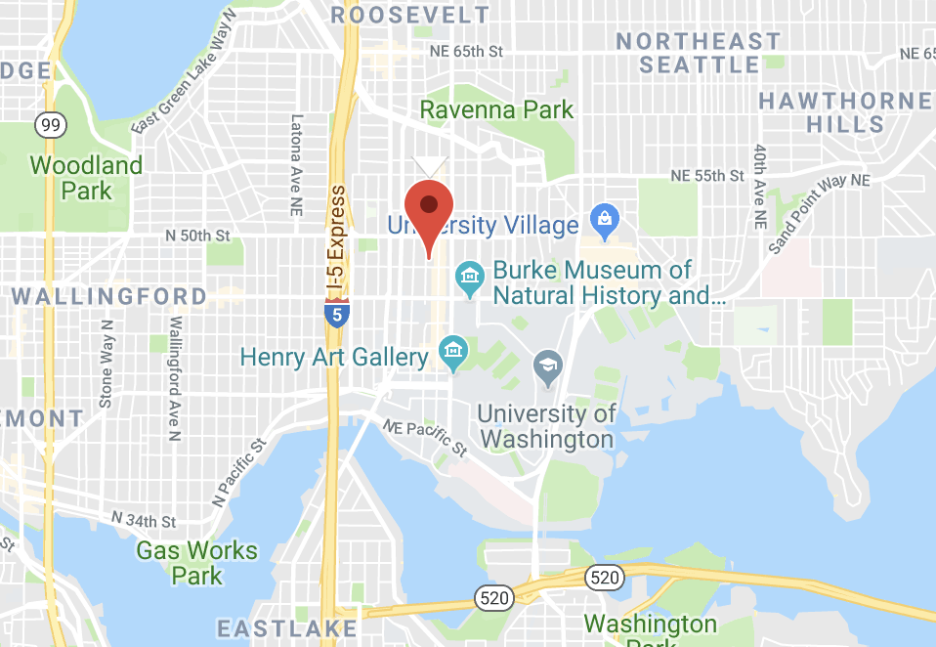

**Location:**

(walking and drive distance approximations are done by google maps)

* It is located 4700 Brooklyn Ave NE in the 98105-area code.
* Located 2 miles away from Seattle centrum.
* Located one block away from University Way and about 15-minute walking distance from the University of Washington, it is located with close proximity to a University, which is essential for student housing.
* Close proximity to food and drinking places, Including grocery market.
  + Safeway (grocery market) is a 2 min walk away.
  + University Ave is 2 min-walking distance away. The street has more than 50 restaurants. 4 sports-bars. 24 places that can serve alcohol.
* Ravenna Park is 0.9 miles away.
* University of Washington athletic facilities are 1.9 miles away.
* 19 theatres within 10 miles
* Zoning: SM-U 75-240 (M1)

**Transportation:**

* Two bus stops are 3-minute walk away. These bus stops connect to routes 45, 71, 73, 70, 67 and 373.
* A current link rail is a 20-minute walk away (1.9 miles). New link rail station coming in 2020 is one block away.
* Direct access to interstate highway, I-5. 5-minute drive from location to highway.
* Sea-tac airport is 18 miles away.

**Visibility**:

* 24 stories tall. Will become the second largest building in the University District. The building will be visible from very far, also from the I-5, which has traffic driving by every day.
* Not many tall buildings around it.
* Is on the corner on the street.

**Demographics:**

MSA? County? Seattle?

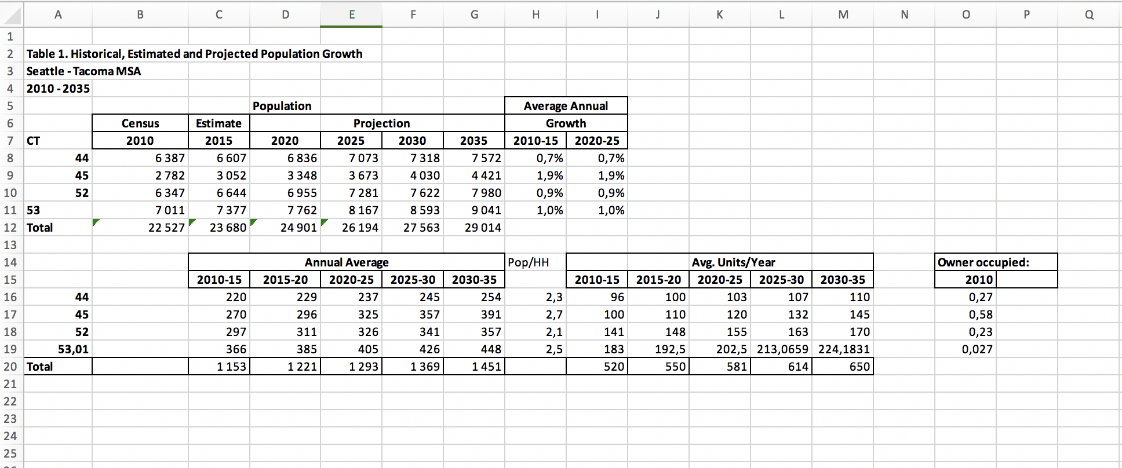

Source: Factfinder.net.gov

Looking at the population and households related to the local area around the apartment complex, I decided to look at data for the four census tracts around the location. Those census tracts include 44, 45, 52 and 53.01. Parts of the census tracts are under the University overlay, which might have an effect on the data and the location.

* In the excel screenshot above, I show the historical, estimated and projected population growth of these census tracts. I also show the population per household and the historical/ estimated / projected for number of units added to the area.

Takeaways from the numbers:

* + - There is a significant population growth in this area. These census tracts depict a population growth of between 1-2 percent per year and this proves that the area is growing and becoming more exciting. This shows that there is definitely a growing demand for housing.
    - !!Comparing the number of units added per year and the rate the population is growing expresses a need for extra units. Not enough units are added to satisfy the increasing population. This is another important factor that proves that new residential estates are needed.
    - I added a box on the right of the excel sheet, which describes the owner-occupied rates in the census tracts. These rates are relatively low for all Census tracts, which means that the areas include many units for rent. This can be another indicator that this market is good for an apartment complex.

**Local Market:** Other significant information about the local and greater area include: (From Factfinder.net.gov)

* + 194,405 students in Seattle.
  + The median age within 98105 area code is 23.6 and 97.8% have a high school degree or higher, compared to 90.8% nationally (of people above 25).
  + 29.2% are below poverty level, compared to 11.3% in Washington.
  + 12 Universities are within 10 miles of Seattle centrum.
  + (according to University of Washington) University of Washington, 15-minute walking distance away, has approximately 46,000 students, where around 7,000 every year are freshman. There are 7,426 international students and 10,190 students from out-of-state.

Takeaways:

* + - This data shows that there is a big population of young people in this area as well as in Seattle. The low median age around the location expresses the need for student housing and that the need is growing.
    - The close proximity to the University shows how the location is attractive to many potential customers and renters. There are also 11 other universities within 12 miles of this location which serves the demand.
    - University of Washington has a diverse student group, where around 18,000 undergraduate students are not from Washington. This proves that student housing in this local community is crucial. With University of Washington having a policy that says that no freshman is guaranteed housing also shows that there is a need for more units.
    - The number of incoming freshman also proves that there are new potential renters every year, or potentially quarter (school calender).
    - Other schools and universities nearby proves that there is a wave of new people wanting to rent in this area every year.
    - Showing a pretty high level of poverty. This is not a good factor, especially for student. With poverty comes more crime. Also an indicator that the UW could be helping the community by taking care of people with less income.# units compared to mkt growth table?

**Income:**

* + According to Factfinder.net.gov, for the four nearest census tracts around the location, 24% have an income below $10,000 per year.
  + The median household income in Seattle has been increasing in the last couple of years. In 2017 a survey by the department of numbers, reported a $82,133 real median household income, which is a 11.18 % increase in the last 3 years. In 2014 the real median income was $ 73,509.
  + Seattle shows a greater increase in real median household income compared to the US. The real median household income of the US has increased by 8.49% in the last 10 years to $60,336 in 2017. It was $54,904 in 2007.
  + The 98105-area code reported a $56,105 median household income in 2017.
  + Seattle also reports an average annual salary of $61,170 compared the US average of $49,630

Takeaways:

* + - The construction is located in a richer environment compared to the US average.
    - Income has been increasing and more people can afford living in an expensive apartment complex.

**Competition**:

* Total housing units: 17,161, in Seattle.
* University of Washington has 12 residence halls, 8 total apartments.

Specific competition to demand:

* + “NOLAN apartments”
    - 0.1 miles from location.
    - Features studios, one and two-bedroom apartments.
    - Not include any luxury features. Decent amount of many amenities. Gym, café.
    - Offer two-bedroom apartments for $ 2260 p/month.
    - Studios for $ 1400 p/ month.
    - One-bedroom apartments for $1500 p/ month.
    - Across the street. Very visible from the same street, but from further away it is not.
  + “TraVigne on Eleventh Avenue”
    - 0.1 miles away from location.
    - Cheaper apartments compared to the m. Not as good amenities.
    - Studio: $ 1300 p/ month
    - Two bedrooms: 2400 p/ month
    - Three bedrooms: 3800 p/ month
    - Not visible.
  + “Wilsonian apartments”
    - More luxury related. Special offers such as indoor jacuzzi and bar.
    - 0.3 miles away from location.
    - Offer one, two and three-bedroom apartments.
    - One-bedroom: unknown
    - Two bedrooms: $ 3150 p/ month
    - Three bedrooms: $ 5500 p/ month
    - Is less visible. Not even close to as tall

Takeaways:

* + - There are many residential student housing apartment complexes nearby.
    - The price range is big, but it also depicted in the offer. The more extra services the housing offers, the more expensive is the offer.
    - The Wilsonian is the most similar offer. It is a luxury student housing complex that offers a variety of different services within the building, similar to “the M”.
    - The price for rent will most likely mirror the offer from the Wilsonian. That will be a direct competitor. But this project will have an edge because it is newer and the visibility is way better.

**Opportunities**:

* The close proximity to the University of Washington is a major opportunity.
* Big young population, low average age.
* Many students. New students every year.
* There is a growing population.
* Income is growing.
* Visibility is tremendous. Will be the second tallest building in UDistrict.

**Constraints**:

* High rent price. Is debatably both a pro and a con, but this can be an issue in a student dominated neighborhood. As the data shows, they have generally a lower income, but they are attending an expensive school. Might prove that they can afford it through family funding. Expensive rents will also limit who can rent in general. Need people willing to pay more.
* The University overlay. The University has to accept the building ideas. Can limit whatever further construction can be done in the area or to the location.
* The tall building changing the local environment. People can complain and make problems.
* The building can create a lot of chaos in the neighborhood. Many more people living there.
* Possibly parking. If there is no parking in the building, there will big access issues.
* Cost of construction might push rents up even higher. Need more in return to finance quick construction.

**Conclusion to investor**:

This 24-story residential student housing apartment complex is located in a market with a lot of demand in a growing neighborhood. I believe this apartment will attract a lot of attention due to its good visibility, and that it is being built at the right time. The University district is growing and a new link rail station (one block away) opening in 2020 will be a game changer in the community. This will allow faster travel from downtown Seattle to north of University of Washington. Students will be drooling to live in this complex, only contemplating about whether the high price is worth it or not. The expensive rent is going to be evident and a more crowded are is going to be created. A 24 story residential complex will consist of many units, which will create more traffic.

I believe this project is worth in investing in, but keep in mind that it will expensive and that it will change the atmosphere in the area. It will bring many new people and a new scenery.